CHEMISTRY MICRO-PROJECT

STUDENTS REPORT.

# TITLE: - DIFFERENT POLYMERS AND THEIR USES. NAME: - ABDURRAHMAN QURESHI

ROLL NO.: - 210451

BRANCH: - COMPUTER ENGINEERING SEMESTER: - 1

* INTRODUCTION: -
* A polymer is any of a class of natural or synthetic substances composed of very large molecules, called macromolecules, which are multiples of simpler chemical units called monomers. Polymers make up many of the materials in living organisms and are the basis of many minerals and man-made materials.
* For example: - Proteins, cellulose, nucleic acids. Diamond, quartz, feldspar, polyethylene, concrete, glass, adhesives, paints, paper, plastics, and rubbers.
* Polymers can be classified into: -
  + Thermoplastics
  + Thermosets
  + Long chain polymers
  + Natural polymers
  + Photopolymers
  + Copolymers
* Characteristics of polymers are: -
  + Low density
  + Low coefficient of friction
  + Good corrosion resistance
  + Good mold ability
  + Excellent surface finish can be obtained
  + Can be produced with close dimensional tolerances
  + Economical
  + Low temperature resistance

# MAIN CONTENT: -

* + Types of polymers: -
* POLYSTYRENE: -

Polystyrene is a synthetic aromatic hydrocarbon polymer made from the monomer known as styrene. Polystyrene can be solid or foamed. General-purpose polystyrene is clear, hard, and brittle. It is an inexpensive resin per unit weight.

It is widely employed in the food-service industry as rigid trays and containers, disposable eating utensils, and foamed cups, plates, and bowls.

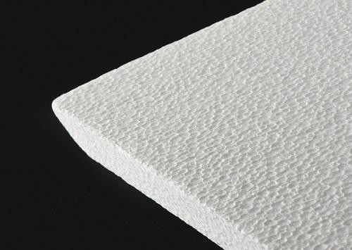

# POLYVINYL CHLORIDE: -

Polyvinyl chloride is the world's third-most widely produced synthetic plastic polymer. About 40 million tons of PVC are produced each year. PVC comes in two basic forms: rigid and flexible. The rigid form of PVC is used in construction for pipe and in profile applications such as doors and windows.

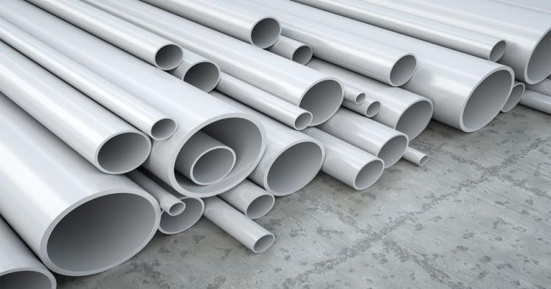

# POLYTHENE: -

Polyethylene or polythene is the most common plastic in use today. It is a polymer, primarily used for packaging. As of 2017, over 100 million tons of polyethylene resins are being produced annually, accounting for 34% of the total plastics market. 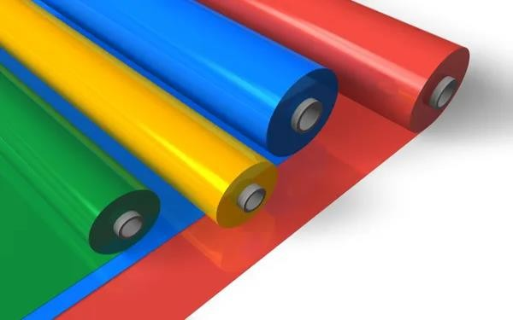

# NYLON: -

Nylon is a generic designation for a family of synthetic polymers composed of polyamides. Nylon is a silk-like thermoplastic, generally made from petroleum, that can be melt-processed into fibers, films, or shapes.

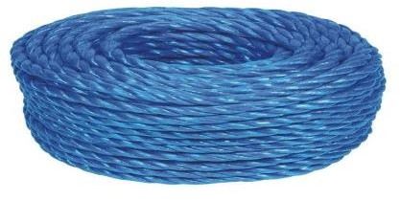

* TEFLON: -

Polytetrafluoroethylene is a synthetic fluoropolymer of tetrafluoroethylene that has numerous applications. The commonly known brand name of PTFE-based compositions is Teflon by Chemours, a spin-off from DuPont, which originally

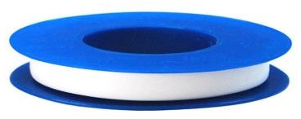

discovered the compound in 1938.

# APPLICATIONS: -

* Polystyrene is widely employed in the food-service industry as rigid trays and containers, disposable eating utensils, and foamed cups, plates, and bowls.

Polystyrene (PS) is also used for producing disposable plastic cutlery and dinnerware, CD "jewel" cases, smoke detector housings, license plate frames, plastic model assembly kits, and many other objects where a rigid, economical plastic is desired

* VC is a versatile material that offers many possible applications, these include: - window frames, drainage pipe, water service pipe, medical devices, blood storage bags, cable and wire insulation, resilient flooring, roofing membranes, stationary, automotive interiors and seat coverings, fashion and footwear, packaging, etc.
* Polythene’s Principal uses are in packaging film, trash and grocery bags, agricultural mulch, wire and cable insulation, squeeze bottles, toys, and housewares.
* Nylon is used for a variety of applications,

including clothing, reinforcement in rubber material like car tires, for use as a rope or thread, and for many injection molded parts for vehicles and mechanical equipment.

* Teflon is used in making waterproof fabric. It is used in making non-stick cookware. It is used in making an anti- friction device. It is used for coating medical appliances (surgical devices).

# CONCLUSION: -

In conclusion, we can say that Polymers are very big molecules made up of many smaller molecules layered together in a repeating pattern, these different types of polymers are very useful in our day-to-day lives and Both natural and synthetic polymers are remarkably involved in comfort and facilitation of human life and are responsible for life itself, for medication, nutrition, communication, transportation, irrigation, container, clothing, recording history, buildings, highways, etc. Both natural and synthetic polymers play a huge role in everyday life, and a life without polymers might not exist. Cells build our bodies, and cells are built of polymers. Plants are built of cellulose, which is a polymer. If polymers would suddenly disappear, life would disappear with it.